DBMS LAB MANUAL

Name:NITHISH KUMAR K Roll.no: 230701218

**Restricting and Storing datas**

**Ex.no.6:**

1.SELECT Last_Name, Salary from EXP6 where SALARY&gt;12000;

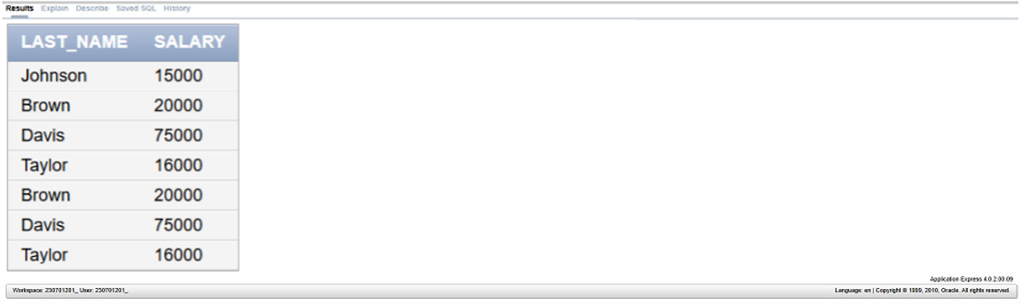

2. SELECT LAST_NAME, DEPT_NO from EXP6 where ENO=176;

3. SELECT LAST_NAME, SALARY FROM EXP6 WHERE SALARY NOT BETWEEN 5000 AND 12000;

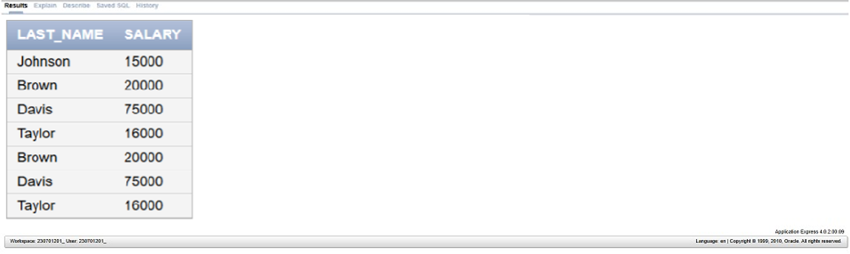

4. SELECT LAST_NAME, JOB_ID, HIRE_DATE FROM EXP6 WHERE

HIRE_DATE BETWEEN ‘02-20-1998’; AND ‘05-01-1998’;

5. SELECT LAST_NAME,DEPT_NO FROM EXP6 WHERE DEPT_NO IN(20,50)

ORDER BY LAST_NAME ASC;

6. select LAST_NAME AS EMPLOYEE, SALARY AS MONTHLY_SALARY FROM

EXP6 WHERE SALARY BETWEEN 5000 AND 12000 AND DEPT_NO

IN(104,105) ORDER BY last_name;

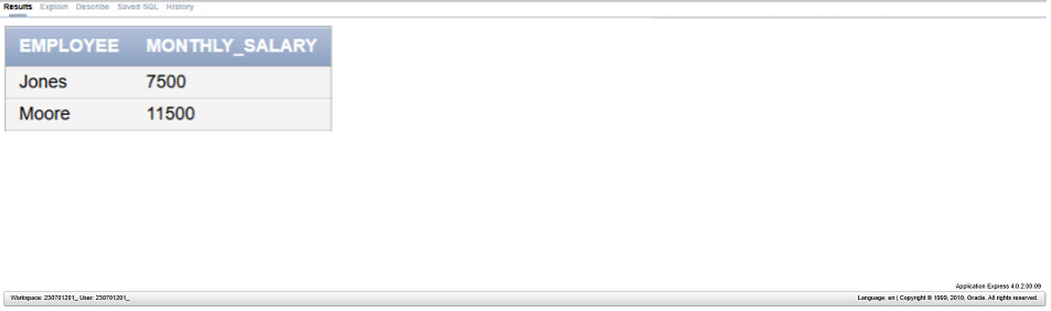

7. select LAST_NAME,HIRE_DATE FROM EXP6 WHERE HIRE_DATE LIKE ‘%1994’;

8. SELECT LAST_NAME,JOB_TITLE FROM EXP6 WHERE JOB_TITLE IS NULL;

9. SELECT LAST_NAME, SALARY, COMMISSION FROM EXP6

WHERE COMMISSION IS NOT NULL ORDER BY SALARY,COMMISSION DESC;

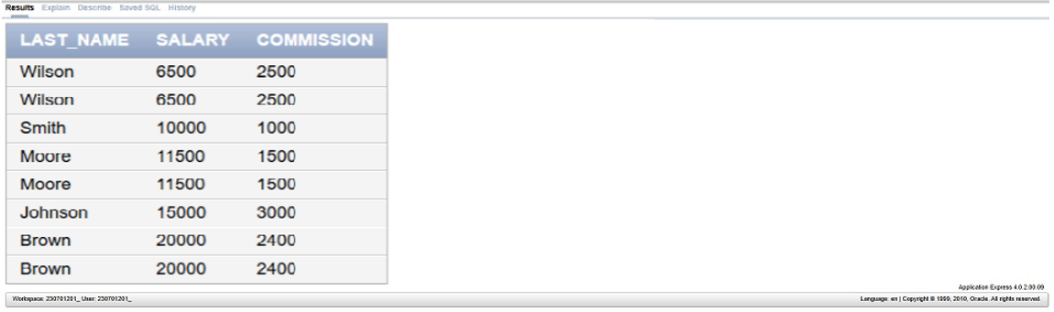

10. SELECT LAST_NAME FROM EXP6 WHERE LAST_NAME LIKE ‘_a%’;

11. SELECT LAST_NAME FROM EXP6 WHERE LAST_NAME LIKE ‘%a’; or LAST_NAME LIKE ‘%e’;

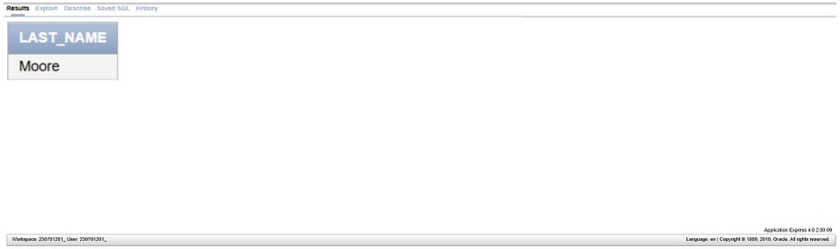

12. SELECT LAST_NAME, DEPARTMENT, SALARY FROM EXP6 WHERE

DEPARTMENT IN(‘HR’,’Finance’;) AND SALARY NOT IN(2500,3500,7000);

